32113 Advanced Database
Assignment 1
<Group ID>

<Report Title>

<
Tiantian Hong 25953391
Alfred John 26225262
Tierney Wang 25959786
Ruihao Qiao 25960699
YAN-ZHEN SU 26137149
Zhaofeng He 13820182

>

Contents
Abstract 1
1 Introduction 2
2 Business Problem 4
2.1 Australian Pet Retail Industry 4
2.2 PetHaven Group Pty Ltd 4
2.3 Business Problem 5
2.3.1 Fragmented Customer Data 5
2.3.2 Inventory Desynchronisation 6
2.3.3 Duplicate and Conflicting Master Data 6
2.3.4 Inconsistent Reporting and Business Definitions 6
2.3.5 Inconsistent Data Governance 6
2.4 Data Use Cases and Requirements 6
3 Review 11
3.1 Data Models 11
3.1.1 Relational Model 11
3.1.2 Dimensional Model 12
3.1.3 Data Vault Model 12
3.1.4 Graph Data Model 12
3.1.5 Hierarchical Model 13
3.1.6 Comparative Summary 13
3.2 Database Technologies 14
3.2.1 Data Lake 14
3.2.2 Data Fabric 15
3.2.3 Data Lakehouse 15
3.2.4 Data Products and Data Mesh 15
3.2.5 Master Data Management (MDM) 16
3.2.6 Comparison of database technologies 16
4 Findings 18
4.1 Synthesis of identified data challenges 18
4.2 Mapping models and technologies to challenges 18
4.3 How the proposed approach addresses the business problem 18
4.4 Outstanding issues and limitations 19
4.5 Recommendations 19
5 Conclusion 21
6 References 22
7 Appendix 24

Figures
No table of figures entries found.
Tables
Table 1: Shaded Blue Table 4
Table 2: Lined Blue Table 4
Table 3: Individual Contribution Table 7

Abstract
Australian households spend over $21 billion a year on pets. Pet retailers now serve customers through stores, e-commerce, mobile applications, loyalty programmes and grooming services at the same time. When these channels operate through separate systems, they can produce fragmented customer records, delayed inventory updates and inconsistent reporting. This happens while poor data quality is estimated to cost organisations millions each year.
This report examines enterprise data management in this context through PetHaven Group Pty Ltd, a fictitious mid-sized Australian omnichannel pet retailer constructed from the published characteristics of comparable firms. Five data problems and six data use cases were derived from the case. The report then reviewed five data models and five database technologies against them using peer-reviewed literature and industry sources. The review found that no single model or technology addresses more than two of the five problems. It also found that the problems form two causal chains with weak governance at the root, so a combined approach is required.
Five recommendations follow: assign named ownership and agreed definitions before any platform investment; use a data fabric to synchronise operational data; establish registry-style master data management for customer and product; defer the reporting platform until master data is stable; and maintain data quality, stewardship and privacy controls as an ongoing activity.

Introduction
Pets are an important family member for humans, and this boosted the pet economy. Early research identified that there are three types of the relationship between consumers and companion animals: animals as friends, animals as self and animals as family members. This means pets are not ordinary consumer objects, but are connected to consumers’ life and relationship (Hirschman 1994). Unlike other retail sectors, this relationship can lead to long-term purchase behaviour, such as membership-based transaction, health and services spending, and product changes across different life stages (Pets at Home 2026). Plus, compared with the conventional customer-product relationship in retail, pet retail is built on the human-animal bond. This produces a special business environment in which sales and service are combined, increasing data complexity (Gromek & Perek-Białas 2022). Because services are offered through different channels and managed in separate systems, large volumes of data are generated from multiple sources. If companies operate these channels and systems separately, this can produce data fragmentation, inconsistent records and delayed inventory updates (Mirzabeiki & Saghiri 2020).
Fragmented or poorly governed data has measurable consequences. Back in 2020, Gartner estimated that poor data quality costs organisations an average of US$12.9 million per year (Gartner n.d.). A recent survey also reports that over one quarter of organisations estimate annual losses exceeding US$5 million due to poor data quality (IBM 2025). From a management perspective, 43% of chief operations officers identify data quality as their top data priority (IBM 2025). In retail, these problems appear as inconsistent product information across channels, delayed inventory updates, duplicate customer records and unreliable reporting (Thaichon et al. 2024). In pet retail, customer-pet-product relationships amplified these issues. A UK petcare retailer reported that siloed and disjointed data is a core barrier to customer service, particularly when linking records across online and offline channels and between customer and pet profiles (Datatonic n.d.).
To deal with these problems, the industry has converged on omnichannel integration, including standardising data capture and sharing, centralising data storage and integrating information systems (Mirzabeiki & Saghiri 2020). Pet Circle, an Australian online pet retailer, found that different teams were using inconsistent metric definitions across distributed transactional databases. In response, they subsequently consolidated these databases into a centralized BigQuery data warehouse (Fivetran 2024; Google Cloud n.d. -b). However, challenges like inventory accuracy (DeHoratius & Raman 2008) and pet-specific data modelling still remain.
To further examine this concern, this report investigates enterprise data management in an omnichannel pet retail context using the fictitious Australian organisation PetHaven Group Pty Ltd. The company was constructed from publicly available material on Australian pet retailers. By modelling real conditions as closely as possible, this allows a specific case to be analysed. PetHaven’s business processes and the corresponding business problems are derived from this material.
The report is a desk-based study that reviews peer-reviewed journal and conference papers on data models and database technologies. Data models provide formal structures for attributes, relationships and constraints, helping organisations to represent complex entity relationships in separate systems. Building on this, the report also reviews database technologies and architectural approaches to explore how data from distributed sources can be stored, accessed, used and governed. Industry reports and documented company cases are also used as supporting evidence for the analysis and as a reference point for the layered architecture proposed.
The objectives are to:
- identify enterprise data management challenges facing omnichannel pet retailers;
- review related data models and their properties based on peer-reviewed studies;
- review relevant database technologies and architectural patterns;
- discuss suitability of these approaches for PetHaven and propose a solution;
In this section, we outline the meaning of enterprise data management, including its economic and social impact. Then in Section 2, the report describes the current state of the Australian pet retail industry and PetHaven’s operating context. After these contents, we identified five business problems. Section 3 reviews five data models (relational, dimensional, Data Vault, graph and hierarchical) and five database technologies by investigating academic literature and recent industry reports. Then Section 4 maps these options to the five problems, proposes a potential solution and sets five recommendations for future plans.

Business Problem

Australian Pet Retail Industry
Australia has a large pet market. According to Animal Medicines Australia (2025), Australia had around 31.6 million pets and 73% of households owned at least one pet. Australians also spent about $21.3 billion on their pets during the year. Of this, pet food, products or accessories accounted for over 50%. This trend encourages pet retailers to expand their sales operations and channel strategies. At present, leading Australian pet retailers such as Petbarn and Pet Circle serve customers through multiple channels. Customers can buy pet food and products in store, online or through mobile apps. Many retailers also offer loyalty membership, delivery, grooming salons, and even appointments with vet clinics (Boomi 2025; Fivetran n.d.).

PetHaven Group Pty Ltd
PetHaven Group Pty Ltd is a fictitious medium-sized Australian pet retailer. To make the case analysis more clear, PetHaven’s characteristics are defined in Table 1, drawing on real world pet retailers such as Greencross and Pet Circle (Google Cloud n.d.-a).
Company characteristic | PetHaven case assumption
Physical Stores | 30 ( across Sydney)
Distribution Centres | 1
Active SKUs | 10,000
Channels | Physical stores, e-commerce website and mobile application
Online share of revenue | 30%
Daily Orders | 2,000 online and 6,000 in-store
Customer records in systems | 300,000
Duplicate customer records | 30,000
Table 1: PetHaven Company Profile
Beyond product sales, PetHaven also operates home delivery, Click and Collect and grooming bookings through an external provider. These services run across all three channels, so one customer interaction may involve several systems. Section 2.4 traces one example of this journey.
The core entities of PetHaven are set out in Table 2. The customer-pet relationship is many-to-many, which means a customer can have several pets, and a pet can be associated with several household members.
Entity | Key Attribute
Customer | Customer ID, contact details and loyalty membership status
Pet | Pet ID, owner, species, breed, age, weight and other notes
Product | Product ID, product name, categories, prices and suppliers
Inventory | Product ID, location (store or distribution centre), quantity and last updated time
Order | Order ID, channel, customer ID (might be null because of unidentified in-store transactions), order date, fulfilment location and status
Order Line | Order Line ID, Order ID, Product ID, quantity, fulfilment location and line status
Booking | Booking time, customer ID, location (store), service type, appointment time and booking status
Table 2: PetHaven entity
PetHaven currently uses several systems to support these activities. A small IT team maintains these systems but is not responsible for how data is defined or managed. Data in each system is maintained by the team that uses it, including store operations, the digital team, supply chain and an external grooming provider. Table 3 defines the present system environment.
System | Related Data | Synchronisation
In-store POS | Store transactions, local stock levels, product codes, loyalty registrations, click & collect records | Real-time locally; no visibility of stock or transactions to other stores
Digital channel (web + app) | Online orders, customer accounts, pet profiles, product catalogue | Reads a central inventory snapshot refreshed overnight; online loyalty sign-up is not linked to in-store registration
Inventory / ERP | Central and distribution centre stock, purchase orders, suppliers | Store movements overnight batch; distribution centre stock updated hourly
Grooming booking | Booking appointments, grooming notes | Third party system which only support manual record, without automated integration
Table 3: PetHaven Current Systems and Data Flows

Business Problem
The core business problem for PetHaven is fragmented and poorly integrated enterprise data. Reading together, Table 2 and 3 show that this issue is not caused by a single fault. First, none of the entities is maintained by a single system. Secondly, there is no system exchanging data with the others in real time.

2.3.1 Fragmented Customer Data (P1)
Customer information is held separately in the in-store POS, the digital channel and the grooming service system, with no mechanism to connect records across them. For example, online loyalty registration is separate from registration at the store, so that PetHaven cannot know which purchases, orders and grooming appointments belong to the same customer. This makes it difficult to analyze customer purchasing behaviour or to recognise returning customers. Research shows that channel integration is important in omnichannel retail because customers expect connected experiences across touchpoints (Thaichon et al. 2024).

2.3.2 Inventory Desynchronisation (P2)
PetHaven’s inventory information is updated at different frequencies across systems, as set out in Table 3. This creates a risk for Click and Collect and cross-location fulfilment. If a customer places a Click and Collect order and the selected store has no stock, staff cannot check availability at the distribution centre or other stores. As shown in Table 2, the inventory entity records quantity and location, so the same product can carry different stock figures in different systems.

2.3.3 Conflicting Master Data (P3)
Even records can be accessed, PetHaven cannot determine which of them refer to the same entity. It now has four separate systems with neither common identifiers nor documented rules. This creates duplicate and conflicting customer and product records. Moreover, the same item can have different codes in POS and ERP systems, and the inventory entity identifies location without a location code. For example, a customer might register in different systems and take several orders, so staff is unable to determine which contact details are correct to process an order.

2.3.4 Inconsistent Reporting and Business Definitions (P4)
PetHaven does not operate a reporting system. Each team extracts data from operational systems using its own schedules and according to its own rules, and consolidates the results independently. As a result, measures such as sales, active customers, stock and fulfillment can be calculated in different ways. For example, one customer order may be fulfilled through several shipments or from more than one location, creating a risk that the same sale is counted more than once. In the real world, a similar issue has been reported by Pet Circle, where teams used different metric definitions and produced conflicting figures (Google Cloud n.d. -b).

2.3.5 Inconsistent Data Governance (P5)
The previous problems also indicate a governance issue. Shared customer, product, inventory and service data needs clear ownership, quality rules and access controls. Khatri and Brown (2010) argue that data governance includes decision rights and accountability for data. This is relevant to PetHaven because data moves between several business processes.

Data Use Cases and Requirements
A typical PetHaven customer journey illustrates how the five problems are connected. A customer registers online, adds products to the cart and selects a store for Click and Collect. If an item is unavailable there, staff need to search stock at other locations. One order may then be fulfilled from more than one location. Later, the same customer and pet profile may also be used for grooming service. Figure 1 shows the journey and the related systems at each step.
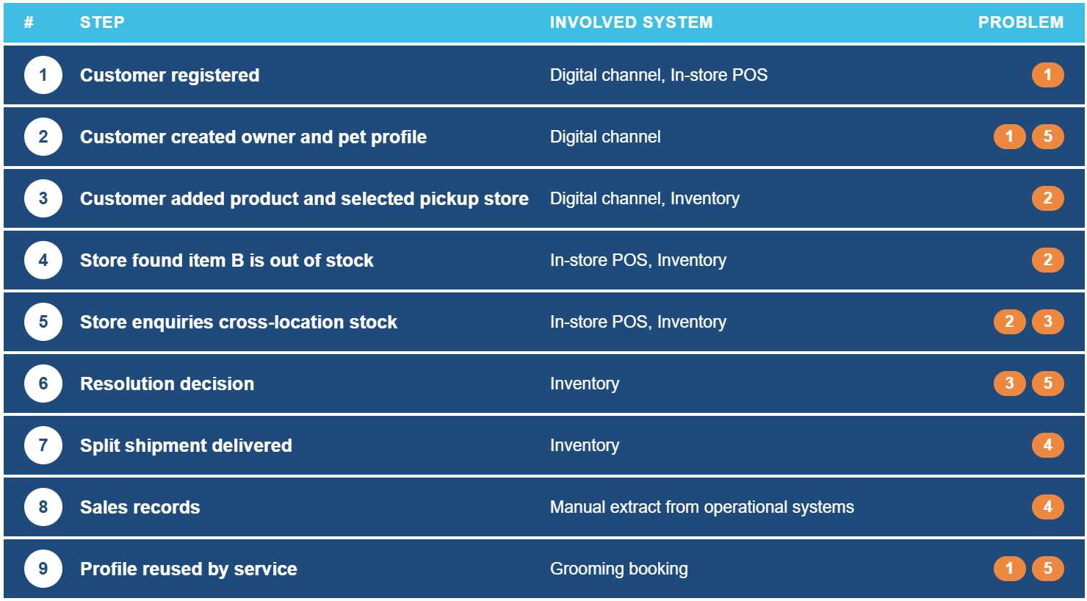
Figure 1. Customer journey steps
The journey is converted into the use cases in Table 4. The requirements are grouped as operational, analytical or governance. Operational requirements support daily transactions and business processes. Analytical requirements support reporting, historical analysis and decision-making. Governance requirements relate to data quality, ownership, definitions and controlled access. A requirement can belong to more than one group because enterprise data is often used for several purposes.
Priority is assessed using MoSCoW. A Must Have is required for a first-stage enterprise data environment. A Should Have is important but has a temporary mitigation strategy. (Agile Business Consortium 2026).
ID | Use Case | Data Requirement | Related Problem | Type | Priority
UC1 | Customer and pet profile | Link customer records across POS, digital channel and grooming system, and keep pet profiles linked to the customer record so services can reuse them | P1 | Operational / Governance | Must Have
UC2 | Inventory visibility | Provide current store and DC stock information before an online or Click and Collect order is confirmed, and allow stock enquiry across locations | P2 | Operational | Must Have
UC3 | Consistent product data | Use common identifiers or clear mappings for products and locations across POS, digital and inventory systems. | P3 | Operational / Governance | Must Have
UC4 | Order and shipment traceability | Keep the relationship between the customer order, order lines, fulfilment location and final status, so split fulfilment is not counted twice. | P4 | Operational / Analytical | Must Have
UC5 | Consistent reporting and historical analysis | Retain integrated historical data and apply shared definitions for measures. Reported results should be traceable to their source data. | P4 | Analytical / Governance | Should Have
UC6 | Data ownership, metadata and access | Shared customer, product, inventory and service data should have a named owner, documented meaning, quality rules and controlled access. | P5 | Governance | Should Have
Table 4: PetHaven Data Use Cases and Requirements
The table shows that PetHaven requires more than one type of data capability. Some requirements support daily processes, such as customer matching and inventory checks, while others support reporting or governance.

Review

Data Models
In this part, five data models will be critically reviewed according to their relevance to PetHaven’s business problem: the relational, dimensional, data vault, graph, and hierarchical models. Each model will be examined for its main structural elements, recent innovation and limitations.

3.1.1 Relational Model
Codd (1970) proposed the relational model as a method to data management based on mathematical theory, in which data is represented as several related tables. Because records are separated across tables but they still need to remain connected, the model requires both entity integrity and referential integrity. Entity integrity ensures that each record can be identified by a primary key that is unique and can not be null. Referential integrity uses foreign keys to maintain valid references between tables (Elmasri & Navathe 2016). In database implementation, these requirements are enforced through integrity constraints. This keeps records and relationships between tables consistent. Therefore, relational models are suitable for structured transactional data which require stable identifiers and consistent relationships.
Nowadays, the model is still widely used in operational business systems (Stonebraker and Pavlo 2024). Relational databases support core operations in many retail platforms. For example, Shopify used MySQL as its main RDBMS (Relational Database Management System) for business-critical data (Gibbs 2019). To meet real-world business needs, newer database systems have some developments. NewSQL systems extend the relational model to support distributed and scalable workloads. These include JSON support, distributed processing and vector search for AI applications (Stonebraker & Pavlo 2024).
However, relational integrity remains limited. Primary-key and foreign-key constraints maintain consistency within a database. They do not match records held in different systems. If the same customer or product is stored under different identifiers in POS or service databases, the relational model cannot know that these records represent the same entity. Cross-source matching would become a data integration problem (Lenzerini 2002; Halevy, Rajaraman & Ordille 2006).

3.1.2 Dimensional Model
The relational model can handle most transactional scenarios. However, when handling complex analytical queries, joining several tables becomes complicated and difficult to understand. To make querying and analysis easier, the dimensional model was proposed. The dimensional model focuses on organizing and structuring information to support query analysis (Kimball and Ross (2013). The main structural components are fact tables and dimension tables. The former records what is happening, holding measurable business events at certain granularities. The latter focus on the perspective from which those facts are viewed, holding descriptive attributes such as product, store, customer and date.
A classical implementation of dimensional modelling is the star schema, where a central fact table is linked to multiple dimension tables. The other method is the snowflake schema, which splits dimension tables into related tables (Kimball & Ross 2013). There are two issues as dimensional models are used to describe business events. Firstly, attributes may change over time. Slowly changing dimensions (SCDs) address this issue by specifying how historical changes are stored. Secondly, the same dimensions may also be used by more than one fact table. Here, conformed dimensions enable multiple fact tables to share the same dimensional attributes, such as customer or product, across the whole enterprise.
Its main limitation is that it depends on clean and well-organized source data. If a customer appears in two systems without mapping, then the dimensional model will treat the records as two separate customers, producing misleading results. In early 2013, Target’s expansion in Canada made a critical error. Because only about 30% of the data was accurate, stores experienced large stockouts even though the system showed stock as available (Castaldo 2016).

3.1.3 Data Vault Model
According to Linstedt and Olschimke (2015), the data vault is a modelling approach aimed at supporting data integration and traceability by preserving historical data from various source systems. The approach consists of three components: hubs, which store unique business keys for core entities such as Customer and Product; links, which describe relationships between entities like a customer who purchases a product; and satellites, which hold time-stamped and source-specific attributes. The data vault model has strong structural adaptability. This is because the design is insert-only and non-destructive, meaning existing records are never altered or deleted, but extended only. So the model does not need to be rebuilt when sources change.
However, under this circumstance, this design produces a high table count, since each entity, relationship and source requires its own hub, link or satellite. As a result, many implementations use metadata to automatically generate these structures, reducing the development cost (Vines and Tănăsescu 2024).
Its main limitation is that data vault is designed to integrate data and retain history rather than to analyze, since querying requires joining many tables. In practice, there will be an additional dimensional layer building on top of the data vault (Linstedt & Olschimke 2015). But this complexity can carry high implementation costs. One reported data vault project had a team of forty specialists, and after one year, the practitioner concluded that a simpler modelling method would have been cheaper and more effective (TIMi 2022).

3.1.4 Graph Data Model
Since analysing data held in tables require repeated joins, the graph data model was proposed, using nodes and edges to represent relationships between entities directly (Robinson, Webber, and Eifrem 2015). Nodes represent entities such as customer, pet and product, while edges represent relationships, such as a customer owning a pet. For instance, to establish that Customer A owns Pet B which is allergic to chicken, no table joins are required. The graph is queried by exploring the path “Customer → Pet → Allergy → Ingredient → Product”. Overall, the graph models are stored as physical structures, allowing multi-hop relationships to be traversed without the performance cost of repeated joins (Robinson, Webber & Eifrem 2015).
The graph model also has further potential. Jaitly et al. (2023) apply it to identify the same customer across different systems, forming a single customer view. This suggests a broader shift towards using the graph model to infer relationships. From an AI-based inference view, unknown relationships can be predicted from patterns in the graph (Rossi et al. 2021).
However, graph models are less suitable for high-volume transactional processing, such as recording a sale. A health insurance company used a graph database to match duplicate claims and remittance records across systems. But they found that as record volumes grew, the pairwise comparisons increased rapidly which degraded performance (Renwick 2026).

3.1.5 Hierarchical Model
The hierarchical model is one of the oldest data models, even developed before the relational model.It organises data as a tree, in which each child record has exactly one parent, while a parent may be linked to many children. Based on this, all records can be navigated from a single root node (Elmasri & Navathe 2016).
Although this model is largely outdated for transactional processing, the tree structure principle has been retained in specific research areas. This applies to document-oriented NoSQL databases holding semi-structured records particularly. Hütter et al. (2022) proposed the JEDI similarity measure for comparing large sets of JSON documents.
Its limitation is that each child can have only one parent, making many-to-many relationships can not be represented without redundancy. This weakness is illustrated by IBM’s Information Management System (IMS), a hierarchical database still used by many large banks for mission-critical legacy applications. In this system, the transaction speed is high, but any change to the business structure requires costly rework (Target 2017).

3.1.6 Comparison of data models
Table 5 summarises the five data models, their core characteristics, strengths and limitations. First, the models are complementary rather than conflicting. An organisation operating several systems would normally use more than one model. For example, a company may use a relational structure for operational data and a Data Vault structure for analytical data. Second, none of these models resolves cross-system structural problems by itself. Relational and hierarchical models focus on data stored within a single database. The dimensional model assumes that matching has already been completed upstream. What's more, the data vault preserves conflicting source keys but does not decide which record is correct. The graph model can reveal candidate matches, but its cost increases as record volume grows. Choosing a data structure is therefore separate from solving cross-system integration.
Data Model | Core Characteristic | Strength | Limitation
Relational | Tabular data linked by primary/foreign keys, normalised for integrity | Strong consistency and integrity within a single system | Cannot match records held in separate systems
Dimensional | Fact tables surrounded by descriptive dimension tables | Consistent, high-performance reporting across the business | Depends on integrated, reliable source data
Data Vault | Hub, link and satellite structure preserving full source history | Integrates multiple sources with full history; adapts to source changes without redesign | Not directly query-friendly; needs a reporting layer built on top
Graph | Nodes and edges storing relationships as first-class, traversable structures | Efficient multi-hop relationship queries and duplicate detection | Not suited to high-volume, simple transactional processing
Hierarchical | Strict tree structure with one parent per record | Fast, simple traversal for naturally one-directional data | Cannot represent many-to-many relationships without redundancy
Table 5. Comparison of data models

Database Technologies
This section critically reviews five database technologies relevant to enterprise data management in this context: the Data Lake, the Data Lakehouse, the Data Fabric, the Data Product/Data Mesh approach, and Master Data Management (MDM), drawing on academic and industry literature.

3.2.1 Data Lake
Traditional databases and data warehouses are mainly designed to manage structured data under predefined schemas. As enterprise data types have become more diverse, the data lake emerged as a more flexible storage approach. It is a centralized repository that can store structured, semi-structured and unstructured data in their original formats. This design allows an organisation to ingest data from heterogeneous sources, such as transactional records, clickstream logs, sensor data or free-text service notes (Sawadogo & Darmont 2021).
A data lake can also store data first and define its structure later when it gets used, which is different from a traditional data warehouse (Sawadogo & Darmont 2021). Thus, new data sources can be ingested quickly, and both raw and semi-processed data can coexist in the same store. This makes a data lake suitable for exploratory analytics, machine learning workloads and situations where source systems and data types are expanding. The main advantages of a data lake are therefore scalability and flexibility.
However, this flexibility still has some risks. Without disciplined metadata management, cataloguing and access control, a data lake can degrade into a “data swamp”. In this state, data becomes difficult to discover, trust or reconcile (Sawadogo & Darmont 2021). This raises three core problems: how organisations can establish that stored data is reliable, how consistency can be maintained, and how data at this volume can be governed. The data lakehouse developed as one response.

3.2.2 Data Lakehouse
The data lakehouse combines the low-cost, flexible storage of a data lake with the transactional reliability and structured management of a data warehouse. Because a data lake stores several data types to store, the lakehouse adds an open table format Iayer, which records what changed in each update and which files belong to which table. This supports atomicity, consistency, isolation, durability (ACID) transactions directly on files held in lake storage (Armbrust et al. 2021; Schneider et al. 2024). This design allows raw and processed data to be managed on one platform, reducing the need to maintain separate data lake and data warehouse systems.
Compared with a standalone data lake, a lakehouse offers stronger governance and query performance; compared with a standalone warehouse, it retains the flexibility to store unstructured or semi-structured data (Schneider et al. 2024). The trade-off is the level of architectural and organizational maturity. If an organisation lacks established practices for data modelling, versioning and access control, repeat or incorrect data may retain.

3.2.3 Data Fabric
However, even where a lakehouse is well implemented, difficulties remain when data continues to be held separately across many systems. To solve this, the data fabric is an integration architecture that connects distributed data sources. By automated, metadata-driven discovery and orchestration, this data technology provides a unified and governed view of data without relocating it into one platform (Abu Rumman & Al-Abbadi 2023). It uses active metadata to identify relationships between datasets and to automate integration flows, so that consistent, governed data can be exposed to downstream applications on demand.
This approach has been adopted in the Australian pet retail sector. Greencross Pet Wellness, which operates over 250 Petbarn stores and 140 veterinary clinics, replaced more than 150 separate point-to-point integrations across its retail, e-commerce and veterinary systems with a single integration platform to synchronize data and support unified digital pet profiles (Boomi 2025). Empirical research supports this as well: because it increases the consistency and timeliness of information reaching decision-makers, data fabric adoption can improve business decision-making and risk management (Abu Rumman and Al-Abbadi (2023)
The main limitations of a data fabric are implementation complexity and its dependence on accurate, well-maintained metadata (Abu Rumman & Al-Abbadi 2023). If poor-quality data is not cleaned first, the connectivity this architecture provides will circulate that data more quickly, leaving the organisation unable to determine which record is correct. A data fabric is therefore most effective as a synchronization and access layer, and depends on underlying data quality and governance practices. To achieve this, companies should also define who is responsible for maintaining the quality. This leads to the data product and data mesh approach.

3.2.4 Data Products and Data Mesh
A more recent approach answers a different question: how ownership and accountability for data should be organized. The data mesh treats discrete, well-documented and independently deployable data products as the primary unit of data management. For instance, a ‘customer profile’ product or an ‘inventory availability’ product. Each product is owned by the domain team that understands it best (Dehghani 2022). In principle, this reduces the likelihood of duplicate or conflicting records emerging in the first place, because each domain publishes one authoritative, trusted version of its data rather than every consumer copying and re-deriving it independently.
The main limitation is organizational: Dehghani (2022) acknowledges that a data mesh requires substantial investment in shared self-serve infrastructure, interoperability standards and federated governance. For organizations that have not yet established basic integration and data quality practices, distributing ownership can be premature, since it assumes a level of data maturity that they have not yet reached.

3.2.5 Master Data Management (MDM)
Master data management (MDM) is used to create and maintain an authoritative view of core business entities, such as customers, products or suppliers (Otto 2012). It focuses on entity resolution rather than how data is stored. When the same customer or product appears in different systems, there will be several versions of the related data records. MDM is the main mechanism for this: it matches and merges these records to create a trusted ‘golden record’.
Otto (2012) also shows that master data architecture decisions are not purely technical: an organization is supposed to also decide how MDM is implemented. There are several implementation ways (Otto 2012). One is a centralized model that uses one authoritative hub that other systems synchronize with. Another one is a registry-style model that keeps records in their original systems but maintains links between matching records. Different MDM implementations affect who is responsible for the authoritative record.
The main challenge is defining reliable matching and merging rules. If the rules are too broad, different customers or products may be incorrectly merged. If they are too strict, duplicate records may remain. So, as with the other technologies reviewed, an MDM platform also depends on consistent source data and clear governance rules to remain effective over time.

3.2.6 Comparison of database technologies
Table 6 summarises the five database technologies reviewed below. These five technologies did not emerge independently. On the one hand, each responds to a real business pain point. At the same time, each also can respond to a limitation left by the one before it. The data lake provides storage flexibility but weak governance. The lakehouse adds governed analytics, but it still requires data to be brought onto one platform. The data fabric therefore synchronises data that remains distributed across systems. The first three technologies all operate on the data itself. The data mesh and MDM, by contrast, change the focus to who owns it and which version of it should be treated as authoritative.
Database Technology | Core Characteristic | Typical Strength | Typical Limitation
Data Lake | Schema-on-read storage for raw, heterogeneous data | Low cost, high flexibility, rapid onboarding of new sources | Governance risk (‘data swamp’) without strong metadata management
Data Lakehouse | Lake storage with warehouse-grade transactions and governance | Combines flexibility with reliable, governed analytics | Requires mature data modelling and access-control practices
Data Fabric | Metadata-driven virtual integration layer across existing systems | Synchronisation of distributed systems without full migration | Implementation complexity; depends on accurate metadata
Data Products / Data Mesh | Domain-owned, independently published data products | Clear ownership and accountability for data quality | High organisational investment; assumes existing data maturity
Master Data Management (MDM) | Centralised or registry-style platform that matches, merges and maintains one ‘golden record’ per entity | Direct resolution of duplicate or conflicting records into one authoritative version | Matching/merging rules are hard to tune; still depends on consistent source data
Table 6. Comparison of database technologies

Findings

4.1 Synthesis of identified data challenges

Section 2 identified five data challenges at PetHaven: fragmented customer data (P1), inventory desynchronisation (P2), conflicting master data (P3), inconsistent reporting and business definitions (P4), and inconsistent data governance (P5).

Read together, these five problems are not independent of one another. They form two causal chains, one is organisational and the other one is architectural. The logic of this chain can guide PetHaven’s data strategy.

For the organisational chain, P5 lies at the root (P5→P3→P1&P4). This relationship is supported by Haug and Stentoft Arlbjørn (2011), who found that assigning responsibility for maintaining master data had the largest impact on data quality, even more than technical issues. In PetHaven, ownership of shared customer, product and inventory data has never been clearly assigned across systems. No team is accountable for deciding which record is correct when records conflict. As a result, each system creates and keeps its own version of the same entity. This produces P3.

P3 then drives P1 and P4. Duplicate customer records block any single view of the customer across channels, which is P1. Inconsistent product codes and undefined measures let two teams count the same sale differently, and that is P4. Both sit downstream of P3, so they are symptoms rather than independent faults.
The architectural path is separate. P2 comes from how data moves between systems. Each system delivers its data to the others on a fixed and different schedule, and these processes are not at the same time. So the same product can show different stock levels in different systems.

P3 still makes it worse, since staff cannot search stock across locations when product codes differ between systems.

Overall, fixing only P1, P2 and P4 would improve the customer experience, but the underlying causes would remain. The two chains start from different problems, so they need separate fixes that run at the same time.

4.2 Mapping models and technologies to challenges
Table 7 maps all ten options against the five problems, rating coverage as Strong, Partial or None. Strong means the option addresses the problem itself. Partial means it helps, but can not resolve the problem itself. None means it adds nothing useful to that problem.
Model | P1 | P2 | P3 | P4 | P5 | Primary contribution for PetHaven
Relational | None | Partial | None | None | None | Already runs inside POS and ERP; guarantees nothing across systems
Dimensional | None | None | None | Strong | None | Would let the store and digital teams count one Click & Collect order the same way
Data Vault | Partial | None | Partial | Partial | None | Keeps source keys and full lineage when integrating repeat data records
Graph | Strong | None | Strong | None | None | Traverses customer → pet → account to expose the 30,000 duplicate records
Hierarchical | None | None | Partial | None | None | Cannot hold the many-to-many relationship
Technology | P1 | P2 | P3 | P4 | P5 | Primary contribution for PetHaven
Data Lake | Partial | None | None | Partial | None | Low-cost method to store POS, app and appointment data
Data Fabric | Partial | Strong | Partial | Partial | Partial | Use metadata-driven synchronisation across POS, ERP, digital channels and booking systems
Data Lakehouse | Partial | None | None | Strong | Partial | Governed tables holding agreed definitions and rules of core measures
Data Products / Data Mesh | Partial | Partial | Strong | Partial | Strong | Each domain team owns and publishes their own trusted version data
Master Data Management | Strong | None | Strong | Partial | Partial | Matching and merging of duplicate customer and product records
Table 7: Coverage of PetHaven’s data challenges by reviewed data models and database technologies. P1 fragmented customer data; P2 inventory desynchronisation; P3 conflicting master data; P4 inconsistent reporting; P5 inconsistent governance.
Four observations follow from Table 7.

First, no row reaches Strong coverage on more than two problems. Each option was built for a particular purpose, whereas PetHaven’s problems span operational, analytical and organisational concerns. The five technologies complement one another; they are not competing alternatives. A combination is therefore unavoidable.

Second, every data model scores None against P5. That does not reflect that models have weaknesses. A model describes how data is structured; it cannot assign ownership or decision rights. Only technologies that organise accountability can address P5 directly. That points mainly to the data mesh, with the data fabric, lakehouse and MDM contributing less through their metadata and governance layers.

Third, P1 and P3 are best addressed by combining a technology with a data model, rather than using either one alone. MDM provides the mechanism for matching records, while the graph model provides the structure for showing relationships between customers, pets and accounts. This is useful when matches are uncertain or indirect. Jaitly et al. (2023) applied this combination in a Customer 360 context.

Fourth, P2 is the exception. The data fabric addresses it almost entirely, because the problem concerns synchronisation frequency, not structure or ownership.

4.3 How the proposed approach addresses the business problem
Three of these options are of limited use in PetHaven’s situation. The relational model already runs inside the POS and ERP systems. The hierarchical model cannot represent the many-to-many customer and pet relations. The data lake emphasises storage rather than consistency. Beside these, four options address only part of the problem and are not central, so their implementation can be deferred.The Data Vault, dimensional model and lakehouse all suit P4, which sits downstream of P3. But P4 cannot be addressed before P3 is resolved. The data mesh is deferred because PetHaven’s domains lack the specialist staff it requires. This leaves two technologies and one model as the most suitable options for PetHaven at this stage.
4.3.1 Addressing the organisational chain – MDM & Graph Model
MDM can be used to identify records that describe the same customer or product across PetHaven's systems. Then, it links or merges them into one authoritative record. Since all four systems must continue to operate and none is being replaced, the registry approach is quite suitable for PetHaven. (Otto 2012).
The graph model can help to build the relationship structure that this matching depends on. For example, a customer may register at the till with a partner's phone number and use their own number in the website at the same time. To store customers, pets, and accounts as nodes by the graph model, PetHaven can trace the indirect connection between these records. At 300,000 customer records (Table 1), if matching is restricted to records that already share an attribute such as phone number, then the scale limitation is controllable.
Together, these two technologies are useful for linked customer and pet profiles (UC1) and consistent product identifiers (UC3).
4.3.2 Addressing the architectural chain – Data Fabric
A data fabric sits above the existing POS, ERP, digital channel and booking systems. Through active metadata it exposes current stock and transaction data on demand without migrating those systems (Abu Rumman & Al-Abbadi 2023). This replaces the overnight snapshot the digital channel currently relies on and delivers inventory visibility (UC2). Figure 3 sets out the resulting layered architecture and the layer at which each problem and use case is addressed.
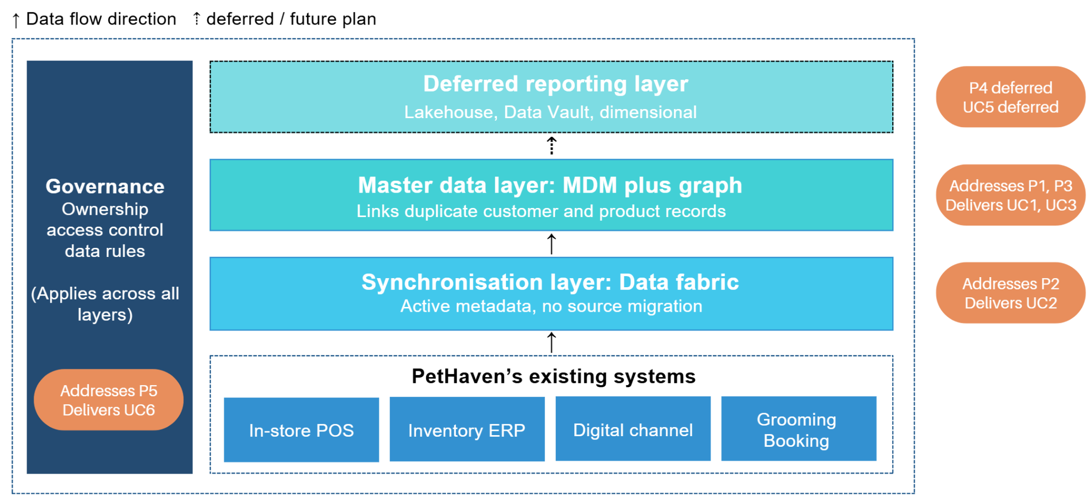
Figure 3: Proposed layered data architecture for PetHaven
4.3.3 The approach in one customer journey
A customer orders in the app. Rather than reading last night’s snapshot, the fabric reads live stock from the selected store, and the order is accepted only if the item is held. When one item is short, staff will search stock at other locations. During this step, the fabric reads across systems and MDM supplies the consistent product codes that make the result usable, so the order is fulfilled from two locations.
Figure 2 shows where the proposed architecture addresses the problems identified at each step of the customer journey.
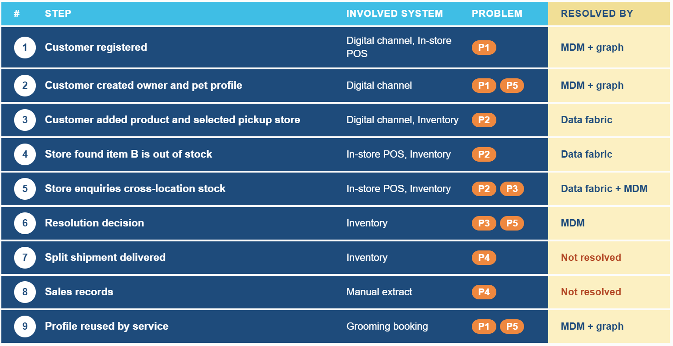
Figure 2: Proposed architecture mapped to the customer journey
The same customer later returns for a grooming appointment. In-store staff open the pet profile, which MDM and the graph layer have linked to an earlier till registration created under a different phone number.
However, the journey does not yet reach the reporting layer. Because the order was fulfilled from two locations, it may be counted twice unless the relationship between order and order lines is preserved (UC4). In addition, the architecture does not determine whether this counts as an in-store sale or an online sale (UC5).

4.4 Outstanding issues and limitations
The proposed approach resolves the structural part of fragmented customer data (P1), inventory desynchronisation (P2) and conflicting master data (P3), but leaves reporting (P4) and governance (P5) only partially covered. In addition, some issues remain within P1 to P3.
Firstly, source data quality. The proposed architecture does not address stock loss, miscounts, returns or damaged goods, all of which affect the accuracy of shelf-level stock data (DeHoratius & Raman 2008), and no synchronisation layer detects this. In other words, inaccurate records are not corrected. Although a data fabric moves data more quickly, this leaves some limitations for P2 unresolved. Customers may still order products that are out of stock. So the remainder is an operational problem at store level.
Second, entity resolution is never fully accurate. When MDM determines whether two records belong to the same person, the outcome is probabilistic rather than certain. The result may be over-merging (Jaitly et al. 2023) , in which two distinct customers are consolidated into a single record, or under-merging, in which duplicate records for the same customer persist. The trade-off cannot be removed only by tuning. At PetHaven, the cost is not equal on both sides. If two pet records are incorrectly merged, allergy and behaviour information may be confused. This turns a matching error into a service risk.
Finally, privacy. PetHaven holds customer records, pet profiles and service histories together, and combines scattered records without defined access and retention rules. This increases the consequences of any breach (OAIC 2026). These rules are management decisions. The architecture can only enforce what the business has already defined.

4.5 Recommendations
These five recommendations are ordered by dependency rather than by the MoSCoW priorities in Table 4.
4.5.1 Unify data ownership and business definitions
Ownership and agreed definitions rank lower in Table 4, but they require only little investment and establish the rules that business processes depend on. PetHaven should assign a named owner to each of the four share domains: customer, pet, product and inventory. Then the company should also document the definitions, data quality rules and access controls. Contested definitions should be determined by the business, not by the data team. For instance, whether a Click and Collect transaction counts as a store sale or an online sale is such a decision. Khatri and Brown (2010) treat governance as the allocation of decision rights and accountability, which is what is absent at PetHaven now rather than any particular tool.
4.5.2 Use a data fabric to synchronise operational data
PetHaven should deploy a data fabric across its systems so stock availability is based on the most recent orders rather than outdated records. In terms of implementation sequence, PetHaven should prioritise a data fabric across the digital channel, inventory and service systems. At the same time, MDM work can proceed in parallel, because these two workstreams address two separate chains and do not conflict with each other.
4.5.3 Establish MDM for customer and product
PetHaven should implement MDM for its shared customer and product entities using the registry approach identified in Section 4.3. In practice, this means building a cross-reference table that maps the customer identifiers in the POS, app and grooming system to one master ID, while keeping the source records in place. There are two decisions that are also required. First, survivorship rules should define which system value is used when records disagree (Otto 2012). For example, contact details may come from the most recently updated channel, while pet health information may come from the grooming system. Second, matches should be classified by confidence level. For instance, high-confidence pairs can be linked automatically, low-confidence pairs should be left alone, and middle-band cases should be sent to the responsible steward. Matching rules should lean towards under-merging. This is because a wrongly merged record can attach one customer’s grooming history and behavioural notes to another customer, while a missed duplicate only causes a customer to repeat information.
4.5.4 Defer the reporting platform until master data is stable
PetHaven should not build a reporting platform until the three preceding recommendations have been implemented. The reporting platform should be a lakehouse with two sublayers (Schneider et al. 2024). The lower layer should use Data Vault modelling, and the upper layer should use dimensional modelling. The Data Vault layer records where each item of data came from and when it was loaded. This layer is needed because MDM may make mistakes when customer records are merged. If a reporting figure is incorrect, the Data Vault layer helps PetHaven trace where the problem occurred, rather than only knowing that the final result is wrong.
4.5.5 Establish data quality controls, stewardship and privacy rules
This recommendation should run through daily operations. PetHaven should build standard checking procedures from three points. First, it should use validation rules, periodic stock counts and reconciliation procedures, especially for the data problems that the fabric cannot correct. Second, people and permissions must be defined clearly. PetHaven needs to decide who checks the data, at which stage the check happens, and how the check is performed. People remain part of the process because data quality still needs ongoing maintenance. Access rights and retention rules should also be defined before customer, pet and service records are combined (OAIC 2026). Third, uncertain matches should be flagged and sent to a named steward for review. If an error is found later during data use or a business process, the record should also be sent back for review. Vilminko-Heikkinen and Pekkola (2019) observed that data ownership remained unresolved across two full MDM projects, which indicates that this is not settled by naming an owner once.

Conclusion
Australian pet retail now operates across physical stores, digital channels and specialised services. Its data structure is more complex than general retail. Because transactions are linked to customers, while services are linked to pets. These entities form many-to-many relationships.
After analyzing a fictional retailer PetHaven, this report identifies five data issues. These problems are connected rather than independent. Weak governance contributes to duplicate records, fragmented customer views, and conflicting reports, while inventory desynchronisation follows a separate architectural path. The comparison of data models and database technologies shows that no single option addresses several issues, so a combined approach is required.
The proposed solution is layered. It uses a data fabric for cross-system visibility and a graph model for master data management. The governance idea runs through all layers. This architecture improves system connection and record consistency, but it cannot correct source data by itself. For this reason, the recommendations begin with ownership and agreed definitions before platform procurement, and then extend to standing quality and privacy controls.
Two limitations apply to the research method. PetHaven is a constructed case and therefore cannot be validated against real operating conditions. The argument also relies on literature rather than implementation. Future work should test the proposed solution in an environment that reproduces the identified fragmentation cases, including cross-system duplicates or shared-ownership pets. Baseline measurement can quantify the duplicates in the customer base and inventory variance. The proposed database solution could then be applied to the same sources, and the results compared before and after implementation.

References
Abu Rumman, A. & Al-Abbadi, L. 2023, ‘Structural equation modeling for impact of data fabric framework on business decision-making and risk management’, Cogent Business & Management, vol. 10, no. 2, https://doi.org/10.1080/23311975.2023.2215060.
Agile Business Consortium 2026, What is MoSCoW prioritization?, Agile Business Consortium, 28 May, viewed 26 August 2026, https://www.agilebusiness.org/resource/what-is-moscow-prioritization/.
Animal Medicines Australia 2025, Pets in Australia: a national survey of pets and people 2025, Animal Medicines Australia, Barton, ACT, viewed 20 August 2026, https://animalmedicinesaustralia.org.au/resources/pets-in-australia-a-national-survey-of-pets-and-people-3/.
Armbrust, M., Ghodsi, A., Xin, R. & Zaharia, M. 2021, ‘Lakehouse: a new generation of open platforms that unify data warehousing and advanced analytics’, paper presented to 11th Annual Conference on Innovative Data Systems Research (CIDR ’21), online, 11–15 January, viewed 22 August 2026, https://people.eecs.berkeley.edu/~matei/papers/2021/cidr_lakehouse.pdf.
Boomi 2025, Greencross Pet Wellness Company boosts personalisation and IT efficiency with Boomi, media release, 13 November, Boomi, viewed 20 August 2026, https://boomi.com/resources/resources-library/boomi-greencross-pet-wellness/.
Castaldo, J. 2016, ‘The last days of Target’, Canadian Business, 1 January, viewed 6 September 2026, https://canadianbusiness.com/ideas/the-last-days-of-target-canada/.
Codd, E.F. 1970, ‘A relational model of data for large shared data banks’, Communications of the ACM, vol. 13, no. 6, pp. 377–387, https://doi.org/10.1145/362384.362685.
Datatonic n.d., Old data, new tricks: how a leading UK petcare retailer is modernising its data platform, case study, viewed 20 August 2026, https://datatonic.com/case-studies/old-data-new-tricks/.
Dehghani, Z. 2022, Data mesh: delivering data-driven value at scale, O’Reilly Media, Sebastopol, CA.
DeHoratius, N. & Raman, A. 2008, ‘Inventory record inaccuracy: an empirical analysis’, Management Science, vol. 54, no. 4, pp. 627–641, https://doi.org/10.1287/mnsc.1070.0789.
Elmasri, R. & Navathe, S.B. 2016, Fundamentals of database systems, 7th edn, Pearson, Boston, MA.
Fivetran n.d., Pet Circle improves customer experience through data, viewed 20 August 2026, https://www.fivetran.com/case-studies/case-study-pet-circle.
Gartner n.d., Data quality, Gartner, viewed 20 August 2026, https://www.gartner.com/en/data-analytics/topics/data-quality.
Gibbs, T. 2019, ‘Five common data stores and when to use them’, Shopify Engineering, blog post, 15 October, viewed 20 August 2026, https://shopify.engineering/five-common-data-stores-usage.
Google Cloud n.d.a, Pet Circle: redefining the pet ownership experience with data-led insights and fast last mile delivery, case study, viewed 5 September 2026, https://cloud.google.com/customers/petcircle.
Google Cloud n.d.b, Unleashing the power of unified data: how Pet Circle transforms pet care with Looker and Google Cloud, case study, viewed 5 September 2026, https://cloud.google.com/customers/petcircle-looker.
Gromek, N. & Perek-Białas, J. 2022, ‘Why is pet goods consumption imperceptible for economists? A scoping review’, SN Business & Economics, vol. 2, no. 11, article 172, https://doi.org/10.1007/s43546-022-00349-5.
Halevy, A., Rajaraman, A. & Ordille, J. 2006, ‘Data integration: the teenage years’, Proceedings of the 32nd International Conference on Very Large Data Bases (VLDB ’06), VLDB Endowment, pp. 9–16.
Haug, A. & Stentoft Arlbjørn, J. 2011, ‘Barriers to master data quality’, Journal of Enterprise Information Management, vol. 24, no. 3, pp. 288–303.
Hirschman, E.C. 1994, ‘Consumers and their animal companions’, Journal of Consumer Research, vol. 20, no. 4, pp. 616–632, https://doi.org/10.1086/209374.
Hütter, T., Augsten, N., Kirsch, C.M., Carey, M.J. & Li, C. 2022, ‘JEDI: these aren't the JSON documents you're looking for...’, Proceedings of the 2022 International Conference on Management of Data (SIGMOD ’22), Association for Computing Machinery, New York, pp. 1584–1597, https://doi.org/10.1145/3514221.3517850.
Jaitly, S., George, D.M., Ganesan, B., Ameen, M. & Pusapati, S. 2023, ‘XEM: explainable entity matching in Customer 360’, Proceedings of the 6th Joint International Conference on Data Science & Management of Data (10th ACM IKDD CODS and 28th COMAD) (CODS-COMAD ’23), Association for Computing Machinery, New York, NY, pp. 248–252.
Khatri, V. & Brown, C.V. 2010, ‘Designing data governance’, Communications of the ACM, vol. 53, no. 1, pp. 148–152, https://doi.org/10.1145/1629175.1629210.
Kimball, R. & Ross, M. 2013, The data warehouse toolkit: the definitive guide to dimensional modeling, 3rd edn, Wiley, Indianapolis, IN.
Krantz, T. & Jonker, A. 2026, A compounding threat: the true cost of poor data quality, IBM, 23 January, viewed 5 September 2026, https://www.ibm.com/think/insights/cost-of-poor-data-quality.
Lenzerini, M. 2002, ‘Data integration: a theoretical perspective’, Proceedings of the 21st ACM SIGMOD-SIGACT-SIGART Symposium on Principles of Database Systems (PODS ’02), ACM, New York, pp. 233–246, https://doi.org/10.1145/543613.543644.
Linstedt, D. & Olschimke, M. 2015, Building a scalable data warehouse with Data Vault 2.0, Morgan Kaufmann, Waltham, MA.
Mirzabeiki, V. & Saghiri, S.S. 2020, ‘From ambition to action: how to achieve integration in omni-channel?’, Journal of Business Research, vol. 110, pp. 1–11, https://doi.org/10.1016/j.jbusres.2019.12.028.
Office of the Australian Information Commissioner 2026, Australian Privacy Principles guidelines, OAIC, viewed 1 September 2026, https://www.oaic.gov.au/privacy/australian-privacy-principles/australian-privacy-principles-guidelines.
Otto, B. 2012, ‘How to design the master data architecture: findings from a case study at Bosch’, International Journal of Information Management, vol. 32, no. 4, pp. 337–346, https://doi.org/10.1016/j.ijinfomgt.2011.11.018.
Pets at Home Group Plc 2026, Annual report and financial statements 2026, Pets at Home Group Plc, Handforth, Cheshire.
Renwick, S. 2026, ‘Why graph databases fail at entity resolution (and what to use instead)’, Tilores, blog post, 18 March, viewed 22 August 2026, https://tilores.io/content/why-graph-databases-fail-at-entity-resolution/.
Robinson, I., Webber, J. & Eifrem, E. 2015, Graph databases: new opportunities for connected data, 2nd edn, O’Reilly Media, Sebastopol, CA.
Rossi, A., Barbosa, D., Firmani, D., Matinata, A. & Merialdo, P. 2021, ‘Knowledge graph embedding for link prediction: a comparative analysis’, ACM Transactions on Knowledge Discovery from Data, vol. 15, no. 2, article 14, pp. 1–49.
Sawadogo, P. & Darmont, J. 2021, ‘On data lake architectures and metadata management’, Journal of Intelligent Information Systems, vol. 56, no. 1, pp. 97–120, https://doi.org/10.1007/s10844-020-00608-7.
Schneider, J., Gröger, C., Lutsch, A., Schwarz, H. & Mitschang, B. 2024, ‘The lakehouse: state of the art on concepts and technologies’, SN Computer Science, vol. 5, no. 5, article 449, https://doi.org/10.1007/s42979-024-02737-0.
Stonebraker, M. & Pavlo, A. 2024, ‘What goes around comes around... and around...’, ACM SIGMOD Record, vol. 53, no. 2, pp. 21–37, https://doi.org/10.1145/3685980.3685984.
Target, S. 2017, ‘The most important database you've never heard of’, Two-Bit History, blog post, 7 October, viewed 20 August 2026, https://twobithistory.org/2017/10/07/the-most-important-database.html.
Thaichon, P., Quach, S., Barari, M. & Nguyen, M. 2024, ‘Exploring the role of omnichannel retailing technologies: future research directions’, Australasian Marketing Journal, vol. 32, no. 2, pp. 162–177, https://doi.org/10.1177/14413582231167664.
TIMi 2022, ‘Data vaulting: from a bad idea to inefficient implementations’, TIMi, blog post, 13 March, viewed 22 August 2026, https://timi.eu/blog/data-vaulting-from-a-bad-idea-to-inefficient-implementation/.
Vilminko-Heikkinen, R. & Pekkola, S. 2019, ‘Changes in roles, responsibilities and ownership in organizing master data management’, International Journal of Information Management, vol. 47, pp. 76–87.
Vines, A. & Tănăsescu, L. 2024, ‘Data vault modeling: insights from industry interviews’, Proceedings of the International Conference on Business Excellence, vol. 18, no. 1, pp. 3597–3605, https://doi.org/10.2478/picbe-2024-0292.

Appendix
The deliverable of this assessment task also includes an appendix (in the end of report) containing the evidence of individual student’s contribution to teamwork and communication (e.g. email communication, task allocated and performed by the individuals in the group assignment).
See below table format examples.
Table 3: Individual Contribution Table
Student Name | Allocated Task | Report Section | Completion Date/Time
Tiantian Hong | Abstract, Introduction, overall logic/flow review, and formatting | Abstract; 1 Introduction (Section 1); full report (logic/flow review and formatting) | 07/09/2026
Yan-Zhen Su | Review Database technologies | 3.2 Database Technologies | 30/08/2026
Alfred John | Review Data models | 3.1 Data Models | 30/08/2026
Tierney Wang | Business problem | 2 Business problem | E 25/08/2026
Ruihao Qiao | Findings | 4.1 - 4.3 | 31/8/2026
Zhaofeng He | Analyze the limitations of each model and technology in addressing the existing five business problems, and provide recommendations and conclusions. | 4.4 outstanding issue  4.5 recommendation  conclusion | 2/9/2026

Tiantian Hong
Evidence of communication
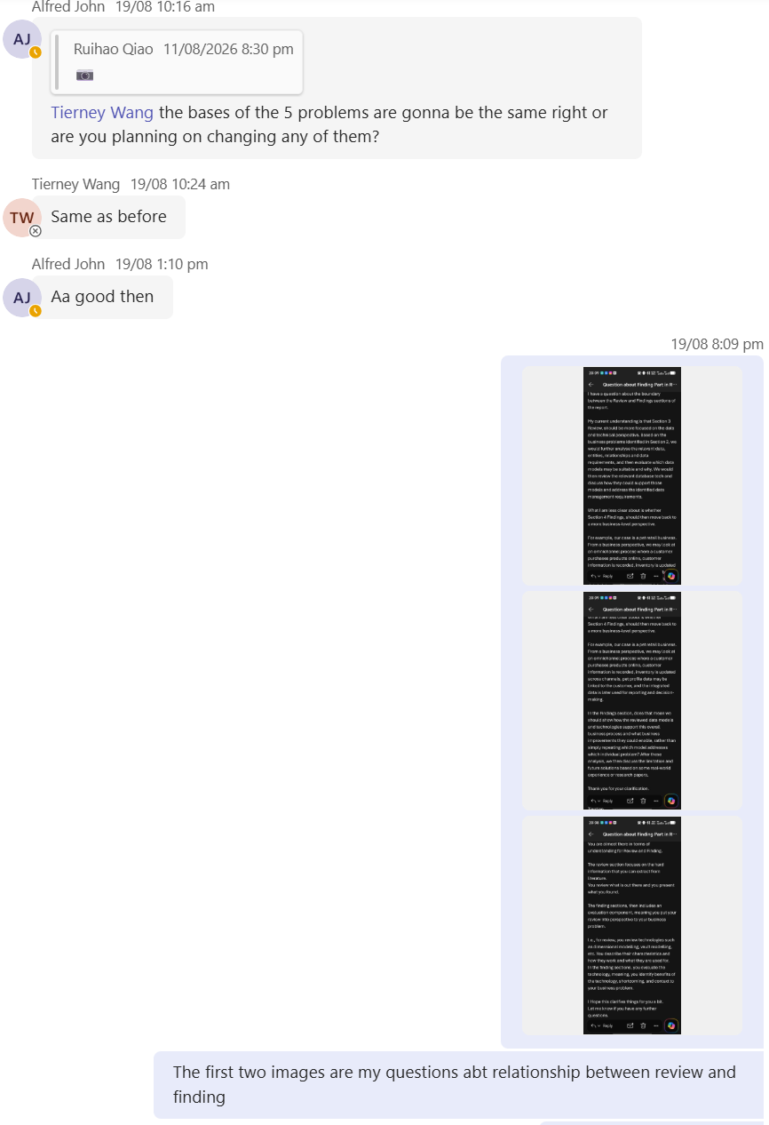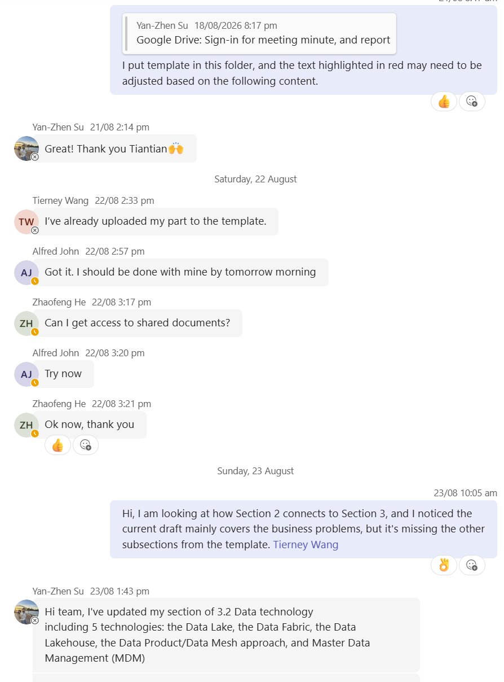
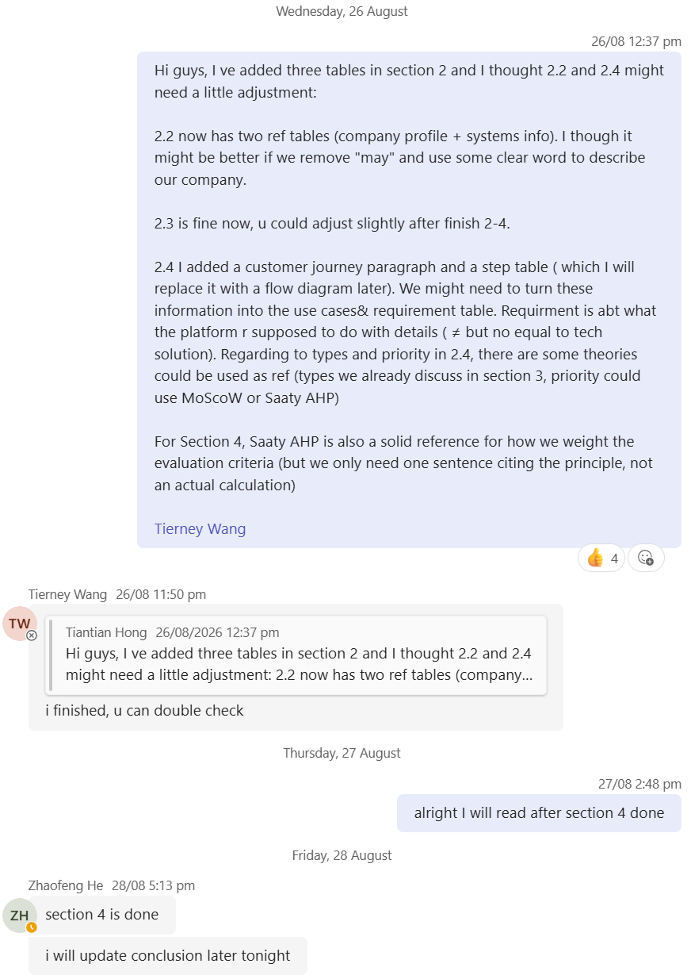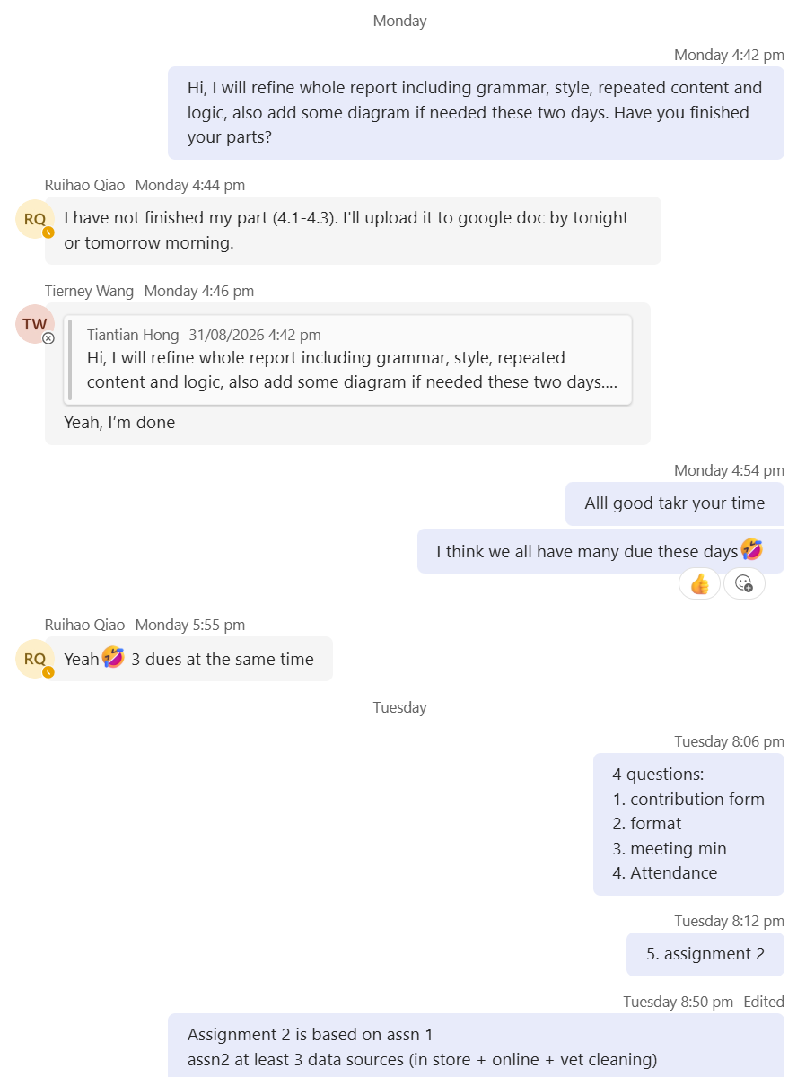
Time Stamp
17/08/2026 Assigned Task:
Assigned Abstract, Introduction, overall logic/flow review, and formatting during Group meeting.
20/08/2026 Finished Work:
Collected background research: pet industry case examples and Australian pet ownership/market data.
21/08/2026 Finished Work:
Completed first draft of Introduction; remaining sections deferred until group members finished their parts.
03/09/2026 - 06/09/2026 Finished Work:
Group members submitted their sections in the 02/09 evening; began reviewing the full report in 03/09; Completed logic and flow review of the full report and revised transitions and adjusted Introduction to align with final content in 05/09.
06/09/2026 Finished Work:
Started formatting and compiling the Appendix.
Evidence of work and feedback and improvement
I did not receive any requested revisions on my Introduction draft. However, after reviewing the full report, I identified several issues with the argument flow and consistency between sections and raised them with the group for discussion. I also clarified the report requirements with our tutor during tutorials and by email, then applied that guidance to the report. After all members submitted their sections on the evening of 3/09, I reviewed every part of the report. I rewrote transitions, resolved inconsistencies between sections, updated the Introduction so that it aligned with the group’s final content, standardised the formatting and compiled the Appendix.
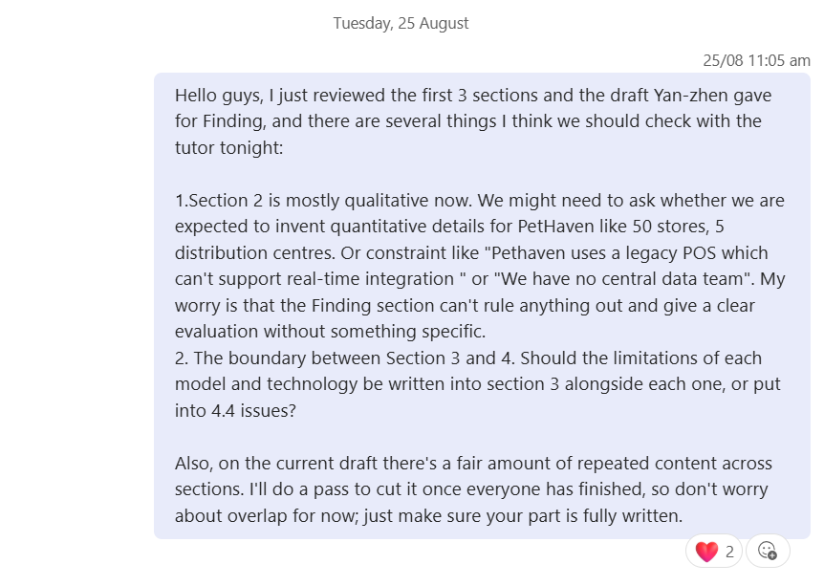
Feedback provided to group members
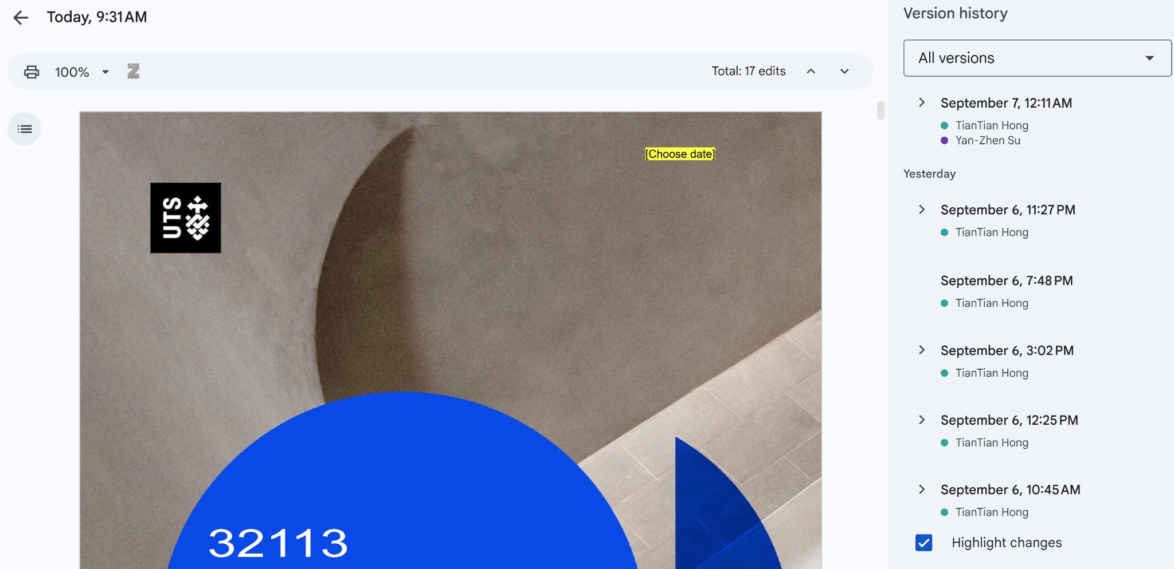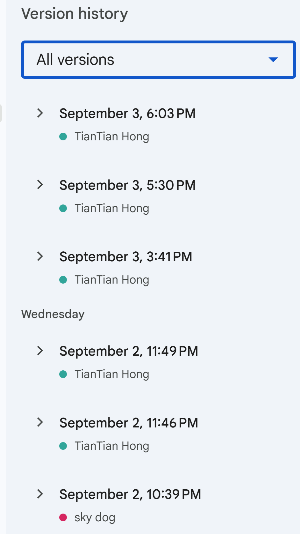
Some of Google Docs version history

  - Yan-Zhen Su

Date & Time | Task / Deliverable | Work Completed
11/08/2026 | Identify data technologies for review | Identified and shortlisted key data technologies to be included in the technology review.
18/08/2026 | Search papers or resources on Data Lake, Data Fabric, and Data Lakehouse | Conducted a literature search and identified relevant academic papers and research publications on Data Lake, Data Fabric, and Data Lakehouse architectures.
23/08/2026 | Search papers or resources on Data Mesh and Master Data Management (MDM) | Searched for and reviewed relevant academic literature on Data Mesh and Master Data Management (MDM) to support the technology review.
30/08/2026 | Write content for reviewing database technologies | Developed review content covering database technologies, including their key characteristics, capabilities, advantages, limitations, and relevant use cases.

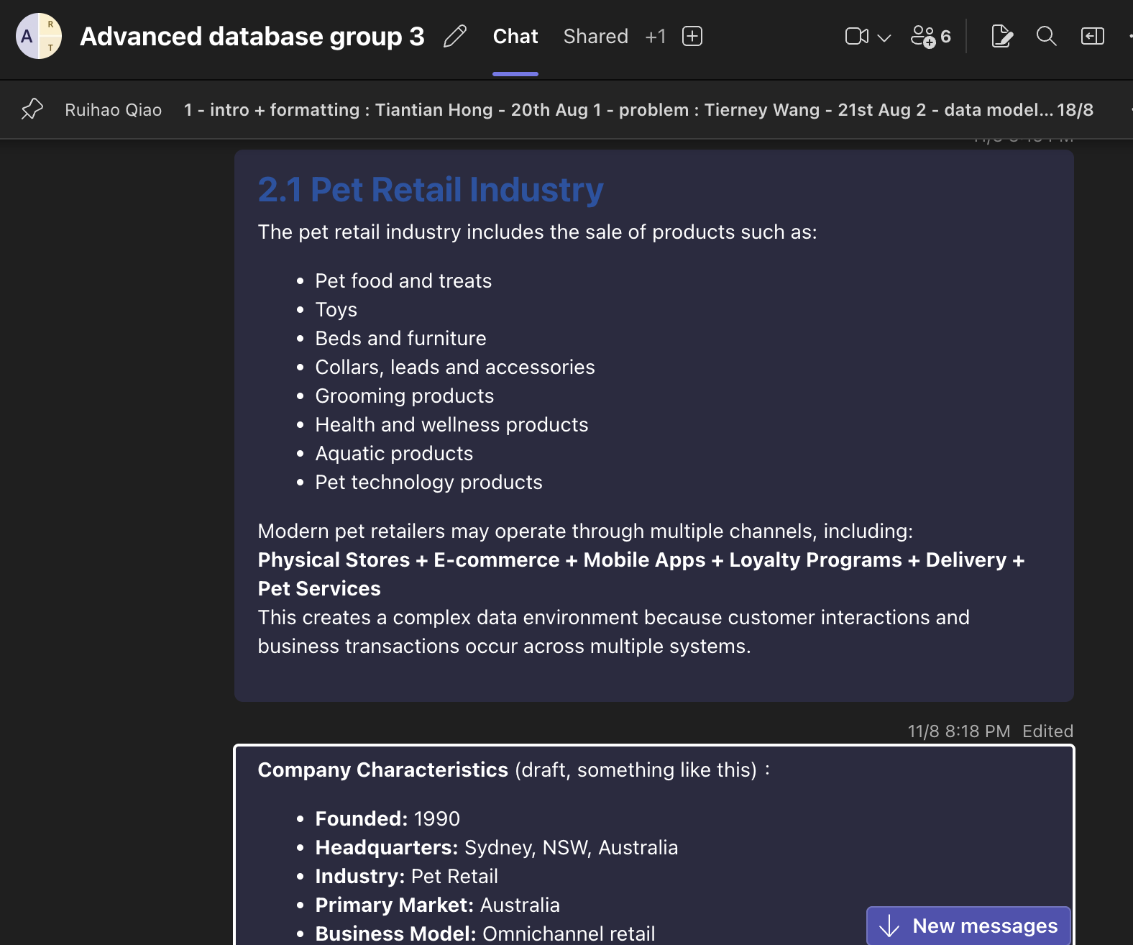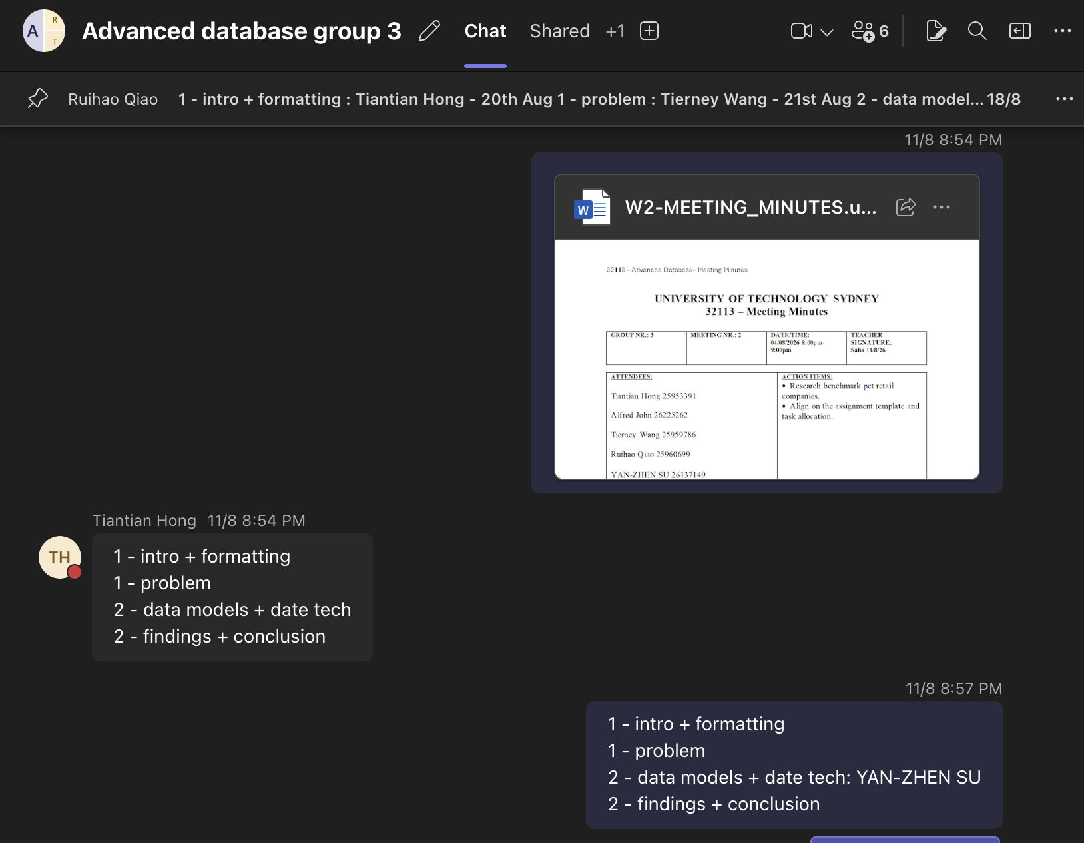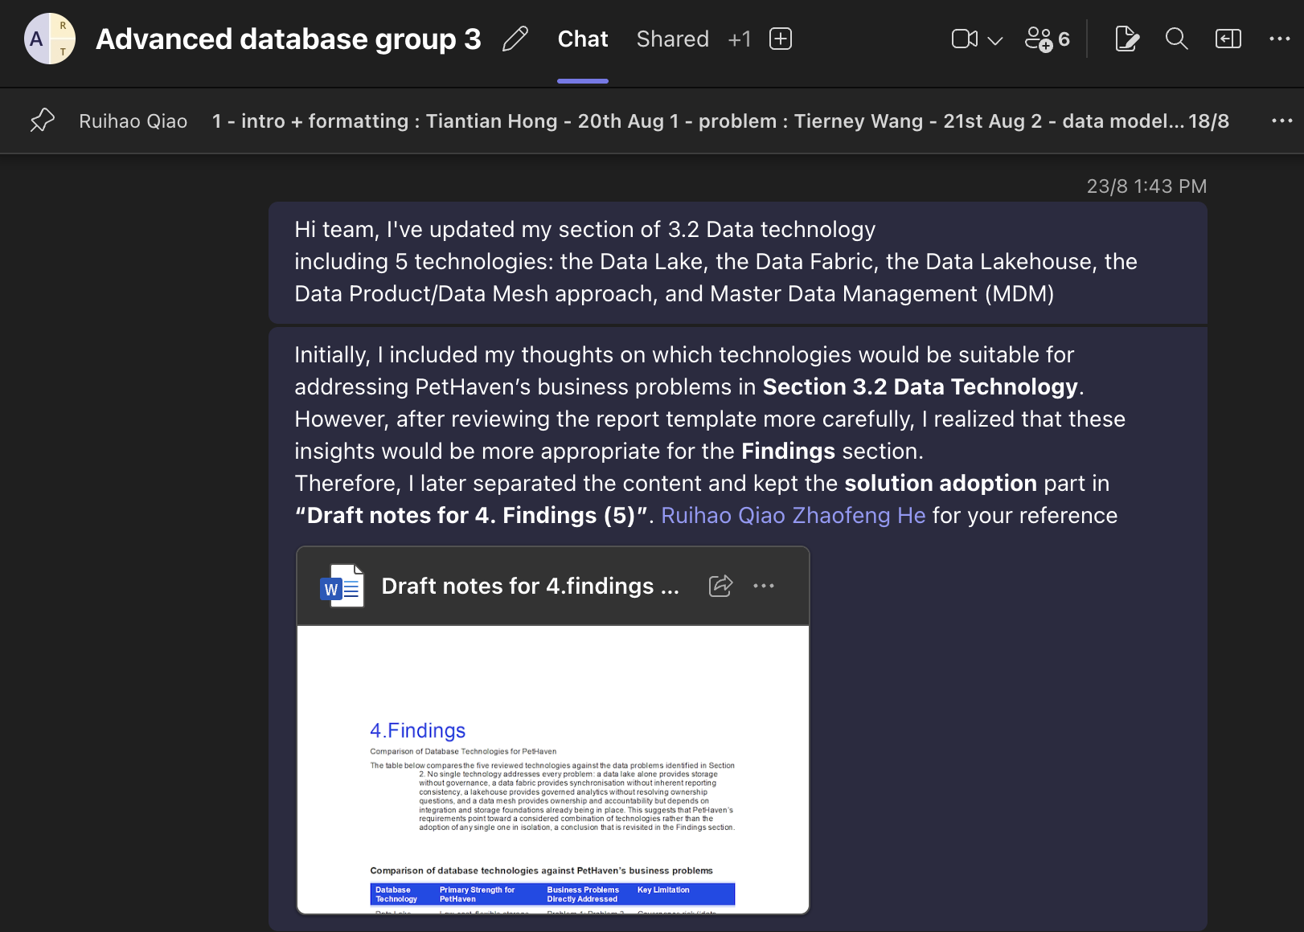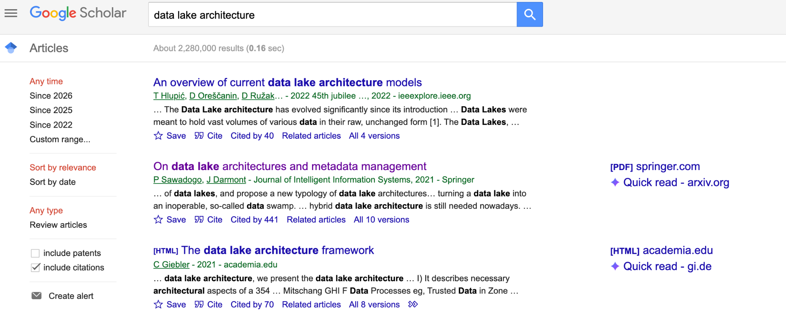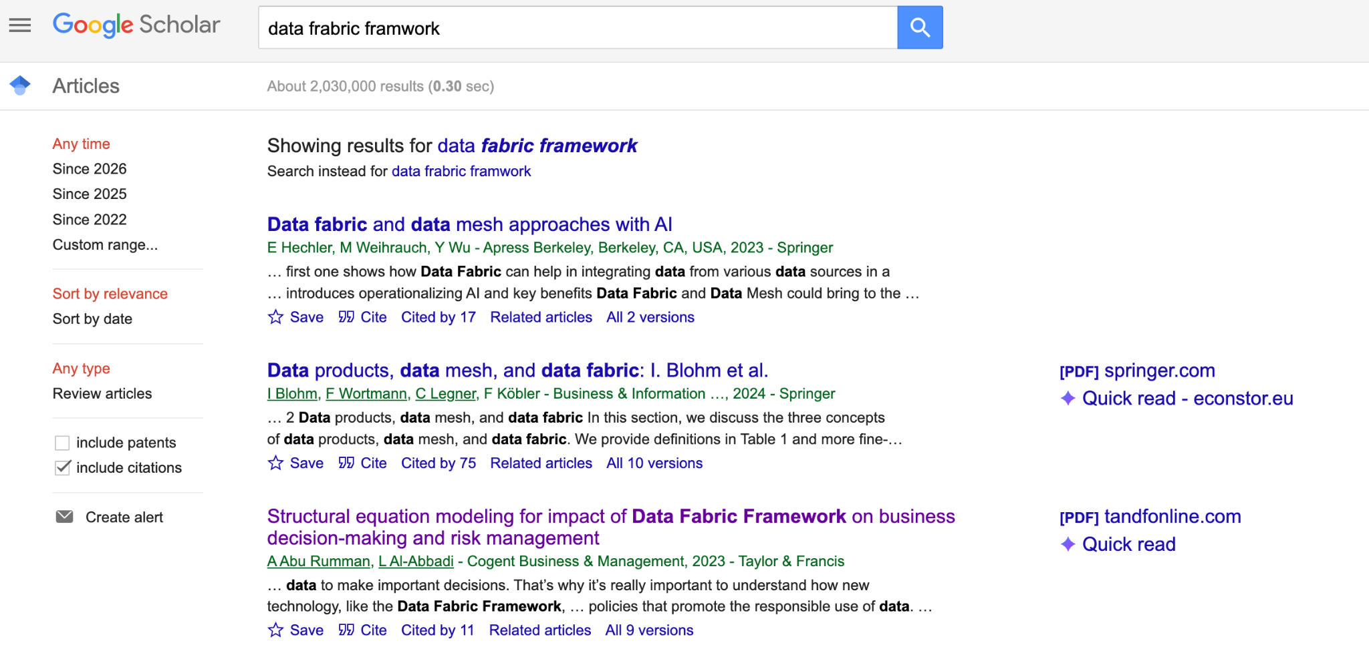
  - Alfred John
My main responsibility in this assignment was Section 3.1 Data Models. My contribution included researching and drafting the review of five data models relational, dimensional, data vault, graph and hierarchical covering each model's classic definition, core structural components, strengths, and limitations.

Date & Time | Task / Deliverable | Work Completed
11/08/2026 | Identify data models for review | Identified and shortlisted key data models to be included in the review (relational, dimensional, data vault, graph and hierarchical).
18/08/2026 | Search papers or resources on Relational, Dimensional and Data Vault models | Conducted a literature search and identified relevant classic and recent academic sources on the Relational, Dimensional and Data Vault models.
23/08/2026 | Search papers or resources on Graph and Hierarchical models | Searched for and reviewed relevant academic literature on the Graph and Hierarchical data models to support the review.
30/08/2026 | Write content for reviewing data models | Developed review content covering each data model, including their core structural components, strengths, limitations and relevant real-world examples.
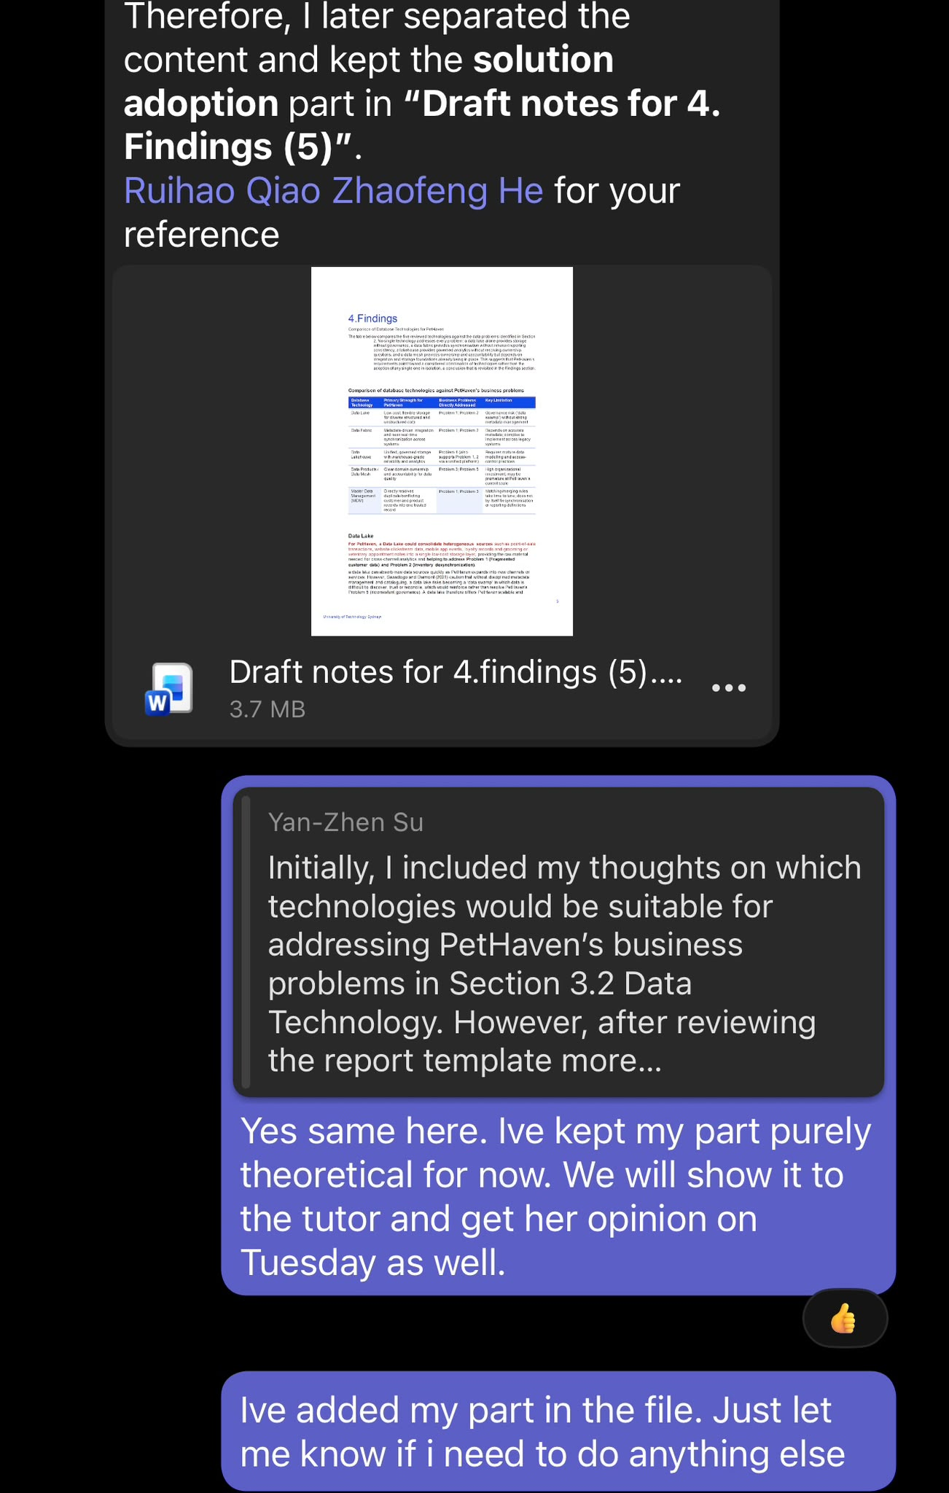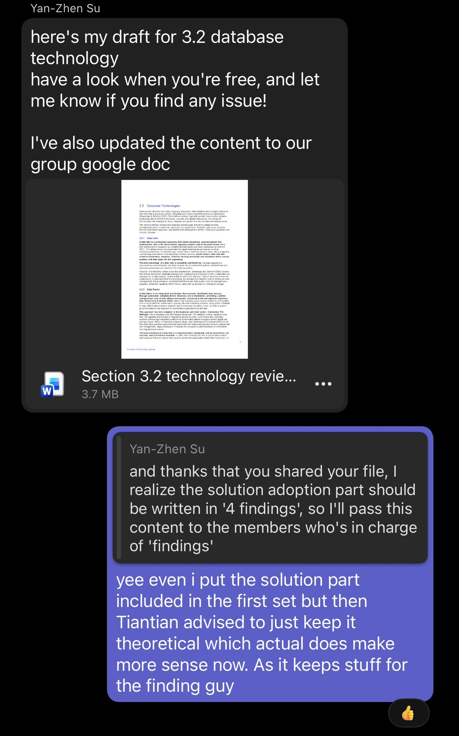
  - Tierney Wang
My main responsibility in this assignment was Section 2 Business Problem and Data Requirements. My contribution included:
Area | Contribution
Industry research | Researched the Australian pet retail industry, including pet ownership, customer spending and the development of omnichannel pet retail. Used academic and industry sources such as Animal Medicines Australia (2025), Thaichon et al. (2024) and Mirzabeiki and Saghiri (2020).
Organisation design | Developed the fictitious company PetHaven Group Pty Ltd and defined its business profile, including stores, distribution centres, sales channels, daily orders, customer records and product range.
System and data analysis | Defined PetHaven’s main systems, including POS, digital channels, inventory/ERP, grooming and wellness booking, and reporting/BI. Identified the main data held by each system and their current synchronisation methods.
Business problem analysis | Identified and analysed five main data problems: fragmented customer data, inventory desynchronisation, duplicate and conflicting master data, inconsistent reporting and business definitions, and inconsistent data governance.
Case evidence | Researched real industry examples, including Greencross/Petbarn and Pet Circle, to support the problems developed for the fictitious PetHaven case.
Customer journey analysis | Developed an omnichannel customer journey to show how customer, product, inventory, order, reporting and service data move across different PetHaven systems.
Data use cases and requirements | Developed eight data use cases and detailed data requirements covering customer identity, pet profile reuse, inventory visibility, master data, order traceability, reporting, governance and flexible digital data.
Requirement classification | Classified the requirements into operational, analytical and governance types and linked each requirement to the relevant business problems.
Requirement prioritisation | Applied the MoSCoW method to classify requirements as Must Have, Should Have or Could Have based on PetHaven’s initial enterprise data management needs.
Referencing | Collected and checked academic and industry references for Section 2 and formatted the sources using Harvard referencing style.
Report integration | Connected the business problems and data requirements in Section 2 with the data models and database technologies reviewed in Section 3, providing a clear basis for the Findings section.
Teamwork | Shared the completed section, tables and research with the group and revised the content based on group feedback to improve consistency between different report sections.
Contribution statement:
I completed the research, case design, drafting and revision of Section 2 Business Problem and Data Requirements. I developed the PetHaven company and system assumptions, identified the five main data problems, and created the customer journey and data use case requirements. I also researched supporting academic and industry sources, applied MoSCoW prioritisation, and helped connect Section 2 with the data models, database technologies and later Findings section.

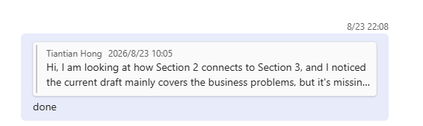
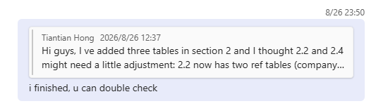

  - Ruihao Qiao
My main responsibility in this assignment was Sections 4.1 to 4.3 of the Findings. My contribution included synthesising five core data problems (P1–P5) from the business problem and review sections, and tracing the causal chain that links them back to weak data governance. I then built the mapping table that rates the ten reviewed data models and database technologies against each problem, using Strong, Partial and None coverage ratings. Finally, I drafted the layered target architecture narrative and produced Figure 2, which shows how the governance boundary, data fabric, master data layer and lakehouse fit together.

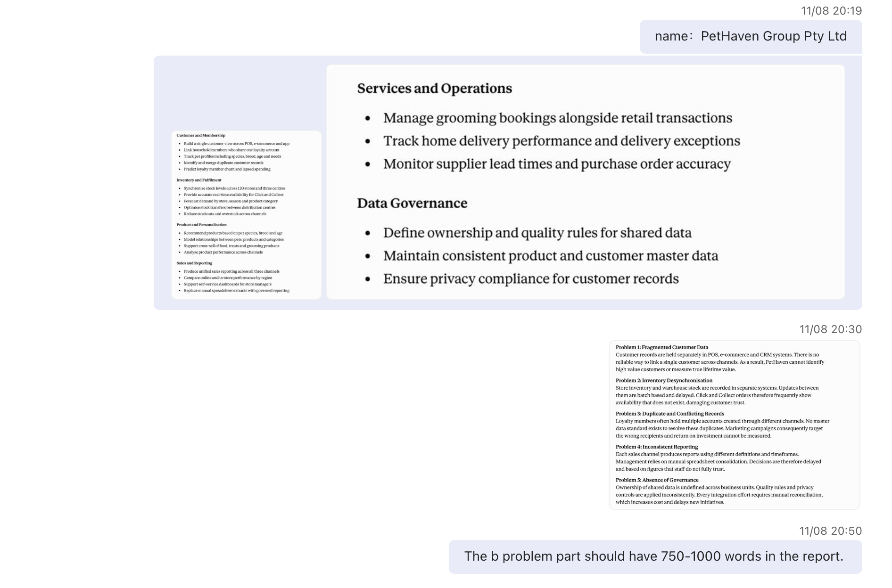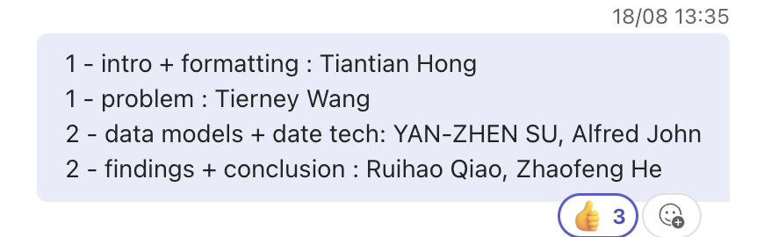

Area | Contribution
Problem synthesis | Consolidated the five data problems (P1–P5) identified across Sections 2 and 3 into a single analytical summary, covering fragmented customer data, inventory desynchronisation, duplicate master data, inconsistent reporting definitions, and weak data governance.
Root cause analysis | Traced the causal chain between the five problems, showing that weak governance (P5) drives master data duplication (P3), which in turn produces fragmented customer views (P1) and unreliable reporting (P4), while inventory desynchronisation (P2) remains semi-independent.
Capability mapping | Built the mapping table that assesses the ten reviewed data models and database technologies against P1–P5, using Strong, Partial and None coverage ratings with a written justification for each rating.
Gap identification | Analysed the mapping results to show where coverage was thin, particularly for governance and cross-system synchronisation, which no single model or technology addresses on its own.
Architecture design | Drafted the layered target architecture for PetHaven and produced Figure 2, covering the governance boundary, the data fabric synchronisation layer, the MDM and graph master data layer, and the lakehouse with its Data Vault and dimensional sublayers.
Referencing | Sourced and verified the academic references supporting Sections 4.1 to 4.3, including Khatri and Brown (2010), Otto (2012), Dehghani (2022), Linstedt and Olschimke (2015), and Kimball and Ross (2013).
Report integration | Linked the problems and requirements from Section 2 with the reviews in Section 3, so that the Findings follow logically from the earlier sections and feed into the recommendations in Sections 4.4 and 4.5.

  - Zhaofeng He

I am primarily responsible for three deliverables: assessing the issues that the proposed architecture failed to address (4.4), a set of suggestions with a clear sequence and supported by evidence (4.5), and a comprehensive review of the overall argumentation and subsequent directions (Chapter 5).

Allocated Task | Report Section | Completion Date/Time
Drafted the critical evaluation of residual limitations and the sequenced recommendations | 4.4, 4.5 | 28 August 2026
Drafted the report conclusion, synthesising the argument and identifying future work | 5 | 1 September 2026
Revised the recommendations to map each one to its related use case (UC1–UC8) | 4.5 | 3 September 2026

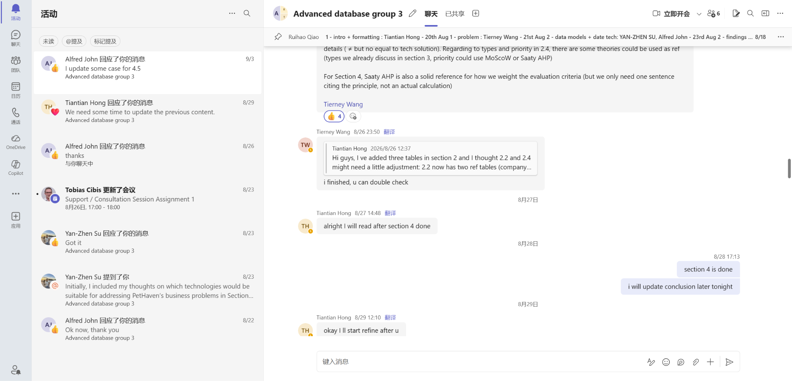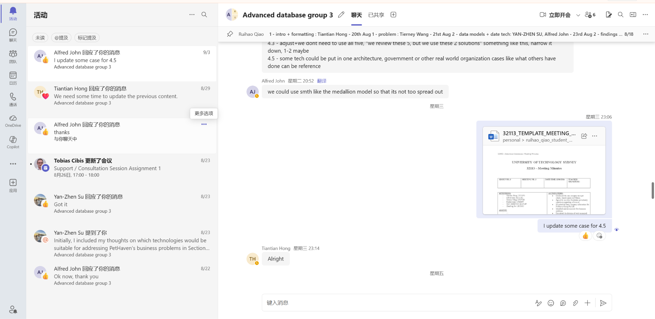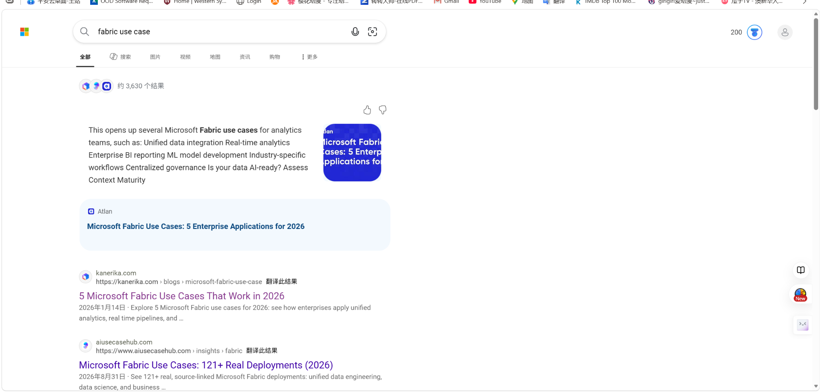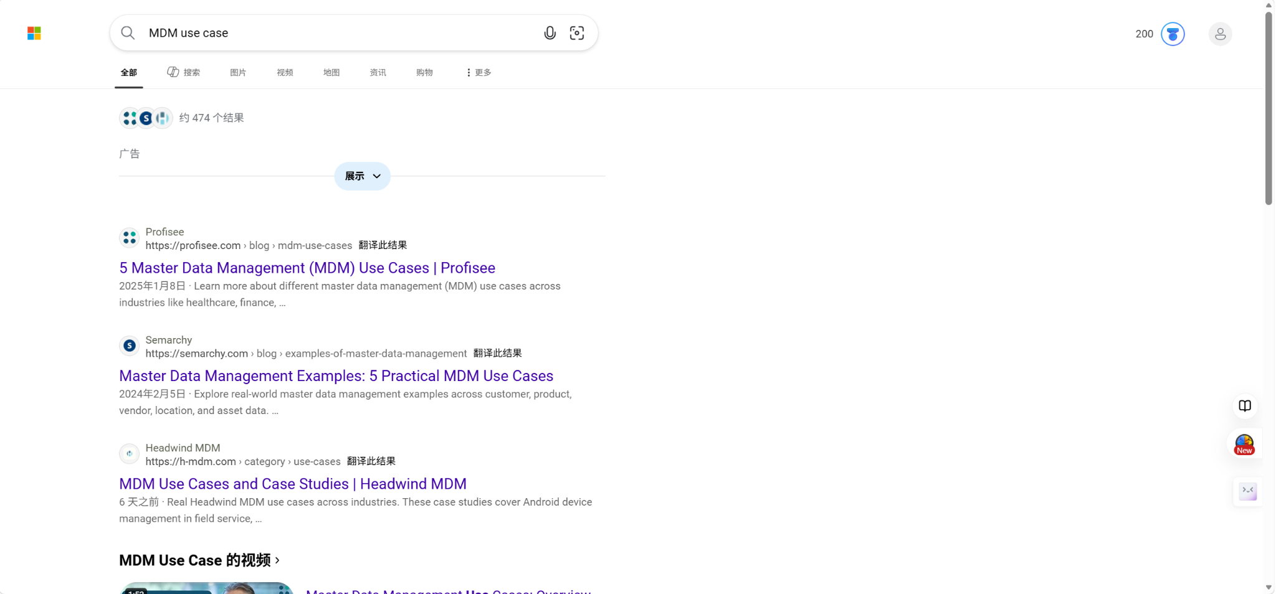

Note: Attach Contribution Form for individual rating and marks.
Overall Individual Contribution:

Student ID | Name | Individual Contribution  (0-100%)
25953391 | Tiantian Hong | 100
26137149 | Yan-Zhen Su | 100
26225262 | Alfred John | 100
25959786 | Tierney Wang | 100
25960699 | Ruihao Qiao | 100
13820182 | Zhaofeng He | 100

